Intent | Implementation | Impact
At Kingsway we aim for our pupils to:  - Develop physical competence, mastering fundamental movement skills, balance, coordination, and control.  - Gain secure knowledge of health, fitness, and wellbeing, understanding the importance of lifelong physical activity and healthy habits.  - Build resilience and confidence, learning how to set goals, persevere, and celebrate achievement.  - Develop teamwork, communication, and leadership skills through games, sports, and collaborative activities.  - Experience competition, learning how to win and lose with fairness, respect, and kindness.  - Build cultural capital by appreciating the value of physical activity across cultures, including sport, dance, and outdoor adventure.  - Recognise the role of PE in fostering spiritual, moral, social, and cultural development, preparing them to become responsible global citizens.  - Be inspired to see PE not just as a subject, but as an essential part of preparing them for the opportunities, responsibilities, and challenges of life in a rapidly changing world. | At Kingsway we will:  - Follow the National Curriculum PE Programme of Study and our progression documents to ensure coverage and progression of skills and knowledge.  - Sequence learning carefully so that pupils develop competence and confidence progressively across a range of activities.  - Provide a balanced programme of individual, group, and team activities, including dance, gymnastics, athletics, games, and outdoor adventurous activities.  - Use high-quality resources and explicitly teach subject-specific vocabulary to strengthen understanding.  - Offer a wide range of opportunities for physical activity both within and beyond the curriculum, including extra-curricular clubs, inter-school competitions, and enrichment events.  - Make purposeful cross-curricular links (e.g. science, PSHE, maths) to show how PE connects to wider learning and real-life contexts.  - Provide memorable and inspiring experiences such as sports days, workshops, and visits from professional athletes that raise aspirations and broaden horizons.  - Regularly check progress through observation, feedback, pupil reflection, and self/peer assessment.  - Ensure all pupils can access and enjoy PE, using adaptive teaching to overcome barriers and ensure inclusion.  - Assess and track pupils’ progress in physical skills, health knowledge, and personal development, addressing gaps and supporting continuous growth. | At Kingsway we strive to ensure pupils can:  - Develop a broad range of physical skills, applying them with confidence across different activities and sports.  - Use subject-specific vocabulary to describe performance, set goals, and give constructive feedback.  - Gain secure knowledge of health, fitness, and wellbeing, applying it to lead healthy, active lives.  - Think critically and reflectively about their own performance and that of others, making improvements with resilience.  - Show teamwork, independence, kindness, and respect in both cooperative and competitive contexts.  - Achieve strong progress, with pupils meeting or exceeding expectations in physical education.  - Be well-prepared for the next stage of their learning, with competence, confidence, and a positive attitude towards lifelong participation in physical activity.  - Leave Kingsway with the skills, habits, and values to truly make a world of difference.
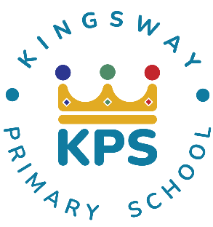
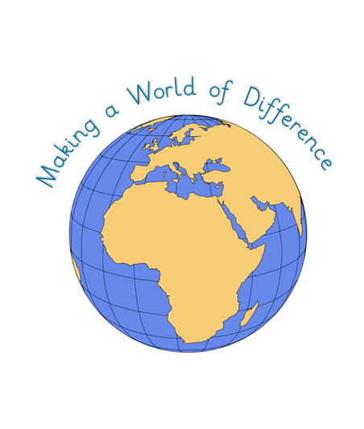
Kingsway Primary School PE Curriculum Intent-Implementation-Impact
At Kingsway, our pedagogy meets the needs of every learner by focusing on four key elements:

- Context: building on prior knowledge so children can revisit and consolidate learning.
- Celebration: fostering purpose and achievement to motivate continued growth.
- Engagement: inspiring and involving learners so they can explore each subject fully.
- Collaboration: developing social skills and applying knowledge in different ways.

