Intent | Implementation | Impact
At Kingsway we aim for our pupils to:  - Develop knowledge of physical and emotional health – understanding how to maintain wellbeing, make healthy choices, and seek help when needed.  - Gain knowledge of relationships – learning how to build positive, respectful, and safe relationships in different contexts.  - Understand sex and relationship education – developing age-appropriate understanding of family life, human development, healthy relationships, consent, and respect.  - Understand economic wellbeing – exploring money, aspirations, careers, and the wider world of work.  - Learn personal and social skills – including resilience, communication problem-solving and our Kingsway school values of kindness, independence, teamwork,  - Appreciate diversity and equality – respecting similarities and differences between people and challenging discrimination.  - Build cultural capital – developing a strong sense of identity, belonging, and responsibility within the school, community, and wider society.  - Become responsible global citizens, prepared for the opportunities, responsibilities, and challenges of adult life in a rapidly changing world. | At Kingsway we will:  - Follow the PSHE Association Programme of Study, statutory guidance for Relationships Education, RSE, and Health Education, and our school’s progression documents to ensure coverage and progression of skills and knowledge.  - Sequence learning to cover key themes of health and wellbeing, relationships, SRE, and living in the wider world.  - Teach PSHE and SRE through dedicated lessons, circle time, assemblies, and cross-curricular links.  - Use age-appropriate, inclusive resources and explicitly teach key vocabulary to strengthen understanding.  - Provide a safe and supportive learning environment where pupils feel confident to share ideas and ask questions.  - Deliver SRE in a way that is sensitive to pupils’ age, background, and emotional needs, while promoting respect and safeguarding.  - Make cross-curricular links (e.g. science, computing, RE, PE) to provide real-life context and deepen learning.  - Provide memorable experiences such as workshops, community projects, and visiting speakers.  - Check understanding regularly through discussion, reflection, and pupil voice activities.  - Ensure all pupils can access and engage with PSHE and SRE, adapting teaching as needed to support inclusion.  - Assess and track pupils’ personal development and understanding of key PSHE and SRE themes, addressing gaps where needed. | At Kingsway we strive to ensure pupils can:  - Develop secure knowledge of health, wellbeing, relationships, and economic understanding.  - Gain age-appropriate knowledge and confidence in understanding their own bodies, development, and healthy relationships.  - Use PSHE and SRE vocabulary confidently to explain ideas and express opinions respectfully.  - Apply personal and social skills to build positive relationships and make safe, informed choices.  - Be able to apply learnt personal and social skills – including resilience, communication problem-solving and our Kingsway school values of kindness, independence, teamwork,  - Think critically about issues affecting themselves, their community, and the wider world.  - Show empathy, respect, and responsibility towards others, appreciating diversity and equality.  - Be well prepared for the next stage of their learning and for life in modern Britain, with the skills and values needed to thrive as healthy, confident, and responsible citizens.  - Leave Kingsway knowing that they have the skills and attributes to be able to at local and global levels to make a world of difference
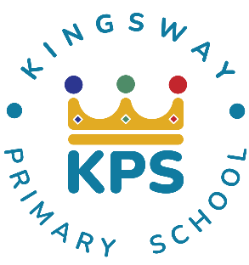
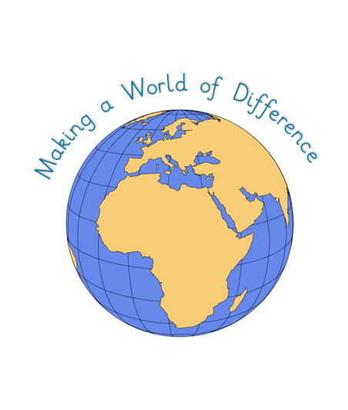
Kingsway Primary School PSHE & SRE Curriculum Intent-Implementation-Impact
At Kingsway, our pedagogy meets the needs of every learner by focusing on four key elements:

- Context: building on prior knowledge so children can revisit and consolidate learning.
- Celebration: fostering purpose and achievement to motivate continued growth.
- Engagement: inspiring and involving learners so they can explore each subject fully.
- Collaboration: developing social skills and applying knowledge in different ways.

