Intent | Implementation | Impact
At Kingsway we aim for our pupils to:  - Become fluent in the fundamentals of mathematics, with secure recall and efficient application of number facts and procedures.  - Reason mathematically by following lines of enquiry, conjecturing, and developing arguments using mathematical language.  - Solve problems by applying their mathematics to a variety of routine and non-routine contexts.  - Make meaningful connections across mathematical concepts and to other curriculum areas.  - Develop resilience, independence and perseverance when faced with challenges.  - See the relevance of mathematics in everyday life, fostering financial literacy and real-world problem-solving skills.  - Build cultural capital by appreciating the role of mathematics in history, technology, and society globally.  - Be inspired to become confident, self-motivated learners, ready for the opportunities and challenges of the future. | At Kingsway we will:  - •Follow the National Curriculum Mathematics Programme of Study and our progression framework to ensure secure sequencing of skills and knowledge.  - •Deliver daily mathematics lessons that combine fluency, reasoning, and problem-solving.  - •Use concrete, pictorial and abstract approaches (CPA model) to secure deep understanding of concepts.  - •Provide opportunities for retrieval and spaced practice to strengthen recall of key facts and methods.  - •Teach mathematical vocabulary explicitly and encourage its precise use in reasoning and explanations.  - •Ensure all pupils are challenged through rich tasks and open-ended investigations.  - Provide additional scaffolding and support where needed to ensure equity of access.  - •Make links between maths and real-life contexts, including STEM opportunities, financial education and cross-curricular projects.  - •Use regular assessment, low-stakes quizzes, and feedback to identify gaps and inform teaching.  - •Offer enrichment opportunities such as maths competitions, clubs, and practical problem-solving events. | At Kingsway we strive to ensure pupils can:  - •Pupils develop fluency, reasoning and problem-solving skills that are secure and transferable.  - •Children confidently use mathematical vocabulary and can explain their thinking.  - •Pupils demonstrate resilience, independence, and enjoyment in mathematics.  - •Learners see mathematics as relevant to everyday life and can apply it to real-world contexts.  - Make meaningful connections across subjects and contexts, deepening their understanding.  - Achieve strong progress across the school, with pupils meeting or exceeding age-related expectations.  - Leave Kingsway with the knowledge, skills, and confidence to succeed at secondary school and beyond, equipped to truly make a world of difference.
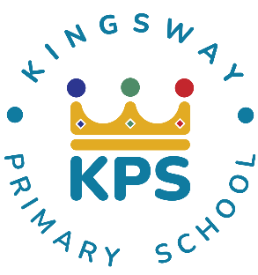


Kingsway Primary School Maths Curriculum Intent-Implementation-Impact
At Kingsway, our pedagogy meets the needs of every learner by focusing on four key elements:

- Context: building on prior knowledge so children can revisit and consolidate learning.
- Celebration: fostering purpose and achievement to motivate continued growth.
- Engagement: inspiring and involving learners so they can explore each subject fully.
- Collaboration: developing social skills and applying knowledge in different ways.

