Intent | Implementation | Impact
At Kingsway we aim for our pupils to:  - Develop secure locational knowledge – identifying continents, countries, cities, rivers, and other key physical and human features.  - Build place knowledge – comparing and contrasting regions of the UK, Europe, and the wider world, recognising similarities and differences.  - Understand human and physical geography – learning about climate, landscapes, natural resources, settlements, trade, and the impact of human activity.  - Strengthen geographical enquiry skills – asking questions, using maps, atlases, globes, and digital mapping, interpreting data, and drawing conclusions.  - Appreciate scale and interdependence – recognising how local, national, and global issues are connected, such as climate change, sustainability, and migration.  - Build cultural capital and global awareness – developing empathy, respect, and responsibility towards people, cultures, and environments.  - Develop resilience, independence, and critical thinking, preparing them to respond to the opportunities and challenges of modern life.  - Grow as responsible global citizens, confident in their ability to make positive contributions both locally and globally. | At Kingsway we will:  - Follow the National Curriculum Geography Programme of Study and our progression documents to ensure secure coverage and progression of knowledge and skills.  - •Sequence learning so pupils build progressively on prior knowledge, deepening understanding of physical and human geography over time.  - •Teach through enquiry-based questions that promote curiosity, critical thinking, and real-world connections.  - •Use high-quality resources and explicitly teach geographical vocabulary to strengthen understanding and confidence.  - •Incorporate a wide range of resources – maps, atlases, digital tools, fieldwork, photographs, and case studies – to bring Geography to life.  - •Make purposeful cross-curricular links (e.g. science, history, art, literacy) to provide meaningful contexts and enhance learning.  - •Provide memorable and enriching experiences, including local fieldwork, outdoor learning, trips, and expert visitors that raise aspirations and widen horizons.  - •Check understanding regularly through retrieval practice, quizzes, discussion, and reflection to ensure knowledge is remembered and applied.  - •Ensure all pupils can access and enjoy Geography, adapting teaching to support inclusion and remove barriers.  - •Assess and track pupils’ progress in knowledge, enquiry skills, and critical thinking, identifying gaps and supporting further growth. | At Kingsway we strive to ensure pupils can:  - Recall and apply secure knowledge of places, people, and processes, making links across contexts.  - Use geographical vocabulary confidently in speaking and writing to explain and analyse their ideas.  - Make meaningful connections between local, national, and global issues, showing awareness of sustainability and interdependence.  - Think critically and creatively about the world around them, interpreting evidence and drawing reasoned conclusions.  - Show curiosity, empathy, and respect for diverse places, people, and cultures.  - Demonstrate resilience, teamwork, and independence through collaborative and individual enquiry.  - Be well-prepared for the next stage of learning, with secure geographical knowledge, transferable enquiry skills, and an appreciation of the world that inspires lifelong learning.  - Leave Kingsway ready to use their geographical knowledge and perspective to truly make a world of difference.
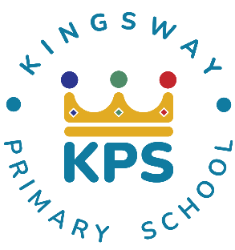
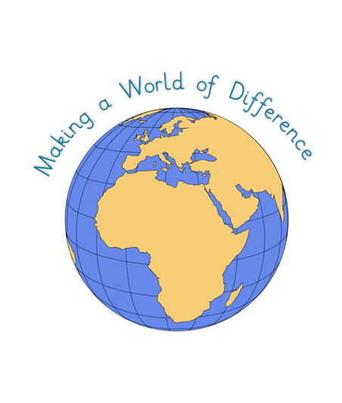
Kingsway Primary School Geography Curriculum Intent-Implementation-Impact
At Kingsway, our pedagogy meets the needs of every learner by focusing on four key elements:

- Context: building on prior knowledge so children can revisit and consolidate learning.
- Celebration: fostering purpose and achievement to motivate continued growth.
- Engagement: inspiring and involving learners so they can explore each subject fully.
- Collaboration: developing social skills and applying knowledge in different ways.

