Intent | Implementation | Impact
At Kingsway we aim for our pupils to:  - •Develop creativity and innovation – generating, developing, and communicating ideas through discussion, sketches, prototypes, and models.  - •Gain technical knowledge – understanding materials, structures, mechanisms, electrical systems, and computing to design and make functional products.  - •Learn practical skills – using tools, equipment, and techniques safely, effectively, and confidently to create purposeful outcomes.  - •Evaluate and improve – reflecting on their own ideas and products, considering the work of others including designers and engineers, and learning from mistakes with resilience.  - •Understand nutrition and cooking – developing knowledge of food, diet, and cooking skills to promote lifelong healthy habits.  - •Build cultural capital – recognising the role of design and technology in society past and present, and appreciating its impact on daily life, innovation, and the wider world.  - •Strengthen problem-solving, critical thinking, and teamwork skills, raising aspirations for future opportunities in STEM and creative industries.  - •Grow as confident, responsible global citizens, prepared to use design and innovation to make a positive difference. | At Kingsway we will:  - Follow the National Curriculum Design and Technology Programme of Study and our progression framework to ensure secure coverage and progression.  - Sequence learning carefully so pupils develop designing, making, and evaluating skills systematically over time.  - Teach through practical, hands-on projects that solve real and relevant problems within a variety of meaningful contexts.  - Use appropriate resources and explicitly teach technical vocabulary to strengthen pupils’ understanding and communication.  - Incorporate a wide range of media, tools, and digital technologies to broaden pupils’ experiences and raise aspirations.  - Make purposeful cross-curricular links (e.g. maths, science, art, computing) to deepen learning and demonstrate transferability of skills.  - Provide memorable enrichment experiences such as STEM workshops, competitions, visits, and opportunities to showcase products within school and the community.  - Regularly check knowledge and understanding through peer review, reflection, discussion, and practical outcomes.  - Ensure all pupils can access and enjoy D&T, adapting teaching to overcome barriers and promote inclusion.  - Assess and track progress in design thinking, technical knowledge, and practical skills, addressing gaps and ensuring strong progress. | At Kingsway we strive to ensure pupils can:  - Develop a wide range of technical and practical skills, applying them with creativity and confidence.  - Use technical and evaluative vocabulary accurately to describe, explain, and critique their own work and that of others.  - Gain secure knowledge of materials, systems, nutrition, and technologies, applying this learning in practical contexts.  - Think critically and creatively, solving problems and developing innovative ideas with resilience.  - Show curiosity, respect, and appreciation for the work of designers, engineers, and innovators across history and cultures.  - Demonstrate teamwork, independence, and perseverance in collaborative and individual projects.  - Be well-prepared for the next stage of their education, with secure technical knowledge, transferable skills, and the confidence to engage with design and technology in the future.  - Leave Kingsway inspired to use creativity and innovation to truly make a world of difference.
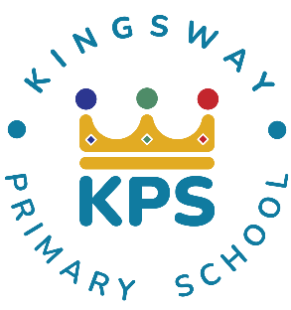
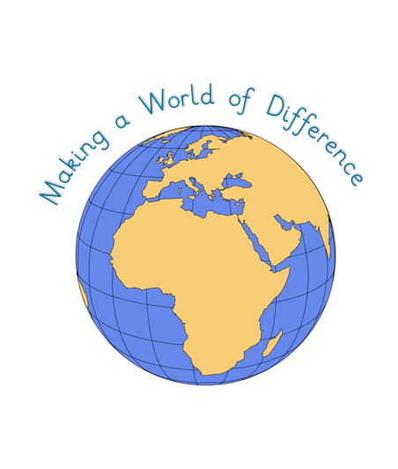
Kingsway Primary School Design Technology Curriculum Intent-Implementation-Impact
At Kingsway, our pedagogy meets the needs of every learner by focusing on four key elements:

- Context: building on prior knowledge so children can revisit and consolidate learning.
- Celebration: fostering purpose and achievement to motivate continued growth.
- Engagement: inspiring and involving learners so they can explore each subject fully.
- Collaboration: developing social skills and applying knowledge in different ways.

