Intent | Implementation | Impact
At Kingsway we aim for our pupils to:  - Develop creativity and imagination – experimenting with ideas, exploring techniques, and expressing their thoughts and feelings.  - Gain knowledge of artists, designers, and craft makers, recognising how art reflects history, culture, and values.  - Learn, practise, and refine artistic skills using a variety of materials, tools, and techniques in drawing, painting, sculpture, textiles, and digital media.  - Evaluate and analyse – reflecting on their own work and that of others using precise artistic vocabulary.  - Appreciate diversity and perspective – valuing a wide range of artistic traditions and expressions across societies and times.  - Build cultural capital, identity, and appreciation of the world through exposure to rich artistic experiences.  - Develop resilience, independence, and teamwork as they solve problems and express ideas creatively.  - Become responsible global citizens, using art as a medium to understand, celebrate, and shape the world around them. | At Kingsway we will:  - Develop creativity and imagination – experimenting with ideas, exploring techniques, and expressing their thoughts and feelings.  - Gain knowledge of artists, designers, and craft makers, recognising how art reflects history, culture, and values.  - Learn, practise, and refine artistic skills using a variety of materials, tools, and techniques in drawing, painting, sculpture, textiles, and digital media.  - Evaluate and analyse – reflecting on their own work and that of others using precise artistic vocabulary.  - Appreciate diversity and perspective – valuing a wide range of artistic traditions and expressions across societies and times.  - Build cultural capital, identity, and appreciation of the world through exposure to rich artistic experiences.  - Develop resilience, independence, and teamwork as they solve problems and express ideas creatively.  - Become responsible global citizens, using art as a medium to understand, celebrate, and shape the world around them. | At Kingsway we strive to ensure pupils can:  - Develop a wide range of artistic skills and techniques, applying them with creativity, confidence, and purpose.  - Use artistic vocabulary to describe, analyse, and evaluate their own work and that of others.  - Gain knowledge of significant artists, designers, and traditions, making connections between art, culture, and the wider world.  - Think critically and creatively, solving problems and developing resilience as they work through challenges.  - Show curiosity, respect, and appreciation for different artistic styles and traditions across societies and time periods.  - Demonstrate kindness, independence, resilience, and teamwork in collaborative creative projects.  - Be well-prepared for the next stage of their learning, with secure artistic skills, cultural awareness, and a love of creativity that will stay with them for life.  - Leave Kingsway with the confidence to use art as a tool to make a world of difference.
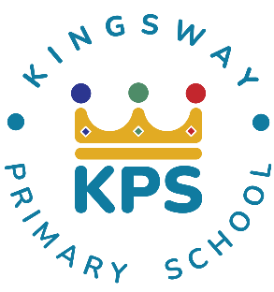
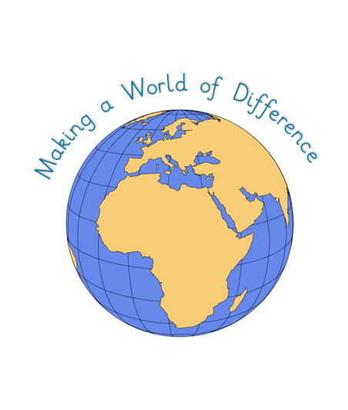
Kingsway Primary School Art and Design Curriculum Intent-Implementation-Impact
At Kingsway, our pedagogy meets the needs of every learner by focusing on four key elements:

- Context: building on prior knowledge so children can revisit and consolidate learning.
- Celebration: fostering purpose and achievement to motivate continued growth.
- Engagement: inspiring and involving learners so they can explore each subject fully.
- Collaboration: developing social skills and applying knowledge in different ways.

