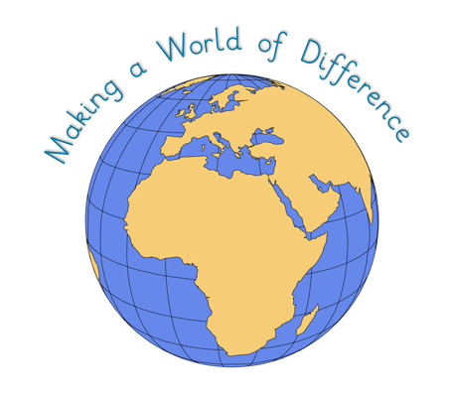
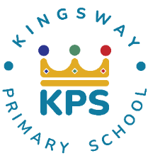
Kingsway Primary School
2025-2026
Curriculum Intent

At Kingsway, our curriculum is ambitious, rich, and
At Kingsway, our curriculum is ambitious, vibrant, designed to prepare children for lifelong learning well beyond our school. We aim to develop the essential knowledge, skills, and understanding which form the building blocks for later life.
Our curriculum goes beyond the statutory requirements of the National Curriculum to provide meaningful, varied experiences, enriched through our commitment to Values-based Education (including British Values). In doing so, we nurture confident, self-motivated pupils who are eager to continue learning throughout their lives.
Our strapline, “making a world of difference,” reflects our belief that every child can make a positive contribution both locally and globally. We support pupils in becoming responsible global citizens who understand their place in an ever-changing world. Through learning about history and how the world has evolved, children gain the knowledge, perspective, and cultural awareness needed to thrive in society today and shape the future with confidence.
We believe every child should have the opportunity to become the best version of themselves. To achieve this, our curriculum:
- Supports children in overcoming barriers and prepares them for their futures.
- Raises aspirations by inspiring pupils and preparing them for the opportunities, responsibilities, and challenges of adult life in a rapidly changing world.
- Embraces the values and culture of our community while widening horizons through a global perspective.
- Promotes spiritual, moral, social, and cultural development through carefully taught values.
- Ensures essential skills in English and Mathematics underpin all learning.
- Weaves core knowledge across subjects to help children make meaningful connections, deepen understanding, and think critically.
- Equips pupils with adaptable skills and transferable knowledge that can be applied to a wide variety of contexts, situations, and experiences.
- Makes learning purposeful through real-life, meaningful contexts.
- Promotes kindness, independence, resilience, and teamwork, equipping pupils for success in the wider world.
- Provides opportunities for enrichment and extension activities that enhance classroom learning, build interpersonal skills, and promote social development.
- Supports physical health and well-being to address local challenges and encourage lifelong healthy habits.
Through this curriculum, we instil a love of learning that will stay with our children long after they leave Kingsway, preparing them to meet the challenges of the future and truly…
Make a World of Difference

