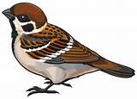
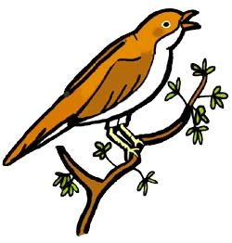
Year 3
Spring Term Newsletter

Happy New Year and welcome back to school! We hope you all had an enjoyable Christmas!
We have a busy term ahead – all the details are below. As usual, please do get in touch with any questions or worries. It’s going to be a great term, so let’s get busy!
Mrs Drake and Miss Weaver

Project
Our project this term is all about Italy. To begin with, we shall be looking at modern day Italy – investigating the culture, the geography, the food (we are going to make pizza!) and finding out as much as we can about life in Italy. After half term, we shall focus on the history of Italy, but more specifically the Ancient Romans. We shall learn about what life was like in Ancient Roman times, and how we still feel the influence of the Ancient Romans today in modern Britain.

Maths
Our Maths this term is focusing on multiplication and division, moving on to length and perimeter, plus measurement. In Year 3, children should be confident with their 2,3,4,5,8 and 10 times tables. Please do practise these at home with your child. Every child has a logon for Times Table Rockstars - it is a great resource for daily practice. We will be sending Maths homework home on a Friday each week. The children seemed very excited about this when we told them! Please send it back in by the following Friday.

Reading
This term, the children will be responsible for changing their reading books every Friday. We encourage children to read their book more than once, particularly as the focus shifts from learning to read the words on the page to comprehension skills. It is vital that your child continues to read on a daily basis at home, and we ask that you encourage your child to read for at least 10 minutes a day as this will significantly improve the outcomes for your child at school. When children read their book at home, they get a stamp in school. The stamps then go into a draw and one lucky winner wins a £5 amazon voucher every term. So the more children read, the more likely they are to win!




Reminders
Please remember to check the class dojo pages regularly for future key information!
Jewellery
We have a policy of no jewellery, apart from a watch and small stud earrings. Please note that for health and safety reasons, earrings must be removed for P.E. lessons. If this is not possible, children must provide their own plasters/tape to cover them. We advise children not to wear any jewellery on P.E. days.
PE Kit
This term, our P.E. days will be Wednesdays and Fridays. We are developing our skills in gymnastics and dance. It is very important that all children take part in the physical aspect of P.E., therefore we ask that your child keeps their P.E. kit in school all week as we may occasionally do P.E. on different days. Please make sure your child has the appropriate kit for both indoor and outdoor P.E. including trainers.

