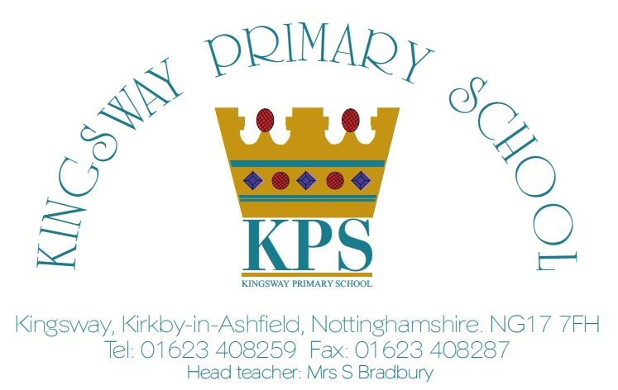

Dear Parent / Carer,
We are very excited to announce that Kingsway will be using ClassDojo to connect with families and share learning with you at home.
ClassDojo is a communication platform that connects teachers and other adults within the school with children and parents. It will allow us to create an online classroom community where messages, updates, home learning, photos and videos can be shared securely.
We’d like all families to join us and sign up for ClassDojo! You can use it on any device: it is a simple, free mobile app for iOS or Android, and can also be used from a computer at www.classdojo.com.
As parents or carers, you will receive a unique website link attached to this letter. You will be asked to sign up using an email address and to create a password before you select your child from the class list. When you are connected, you will be able to access your own child’s online portfolio and any messages the teacher shares on the class or school page. Furthermore, the messaging system will allow a secure and private means of communication between the teacher and parent/carer.
Class dojo will be for you to communicate directly to the teacher regarding day to day minor issues. (e.g. “Hi, Jack has misplaced his bookbag, can you have a look please?” Or “Billy can’t remember what day P.E is, could you help?”)
It is not for informing school of your child absences, or for issues that need to be brought to the headteachers attention. Please continue to contact the school office.
Until the system is fully operational and all are connected, we respectfully ask that parents/carers do not message via ClassDojo. Students are also able to have their own ClassDojo account using a unique code or link sent by their teacher. They’ll be able to see learning posted by their teachers, share their learning and customize their monster avatar.
Find out more about ClassDojo, and how it is safe and simple for everyone: http://kingsway.sch.uk/classdojo/ www.classdojo.com/privacycenter
We believe ClassDojo will be an excellent tool for teachers, parents and children to ensure that we build a strong link between school and home. We hope that all of you take up the opportunity and join our ClassDojo school community. If you have any difficulties in signing up, please contact Mr. Painter via the school office at: office@kingsway.notts.sch.uk.
Best wishes,

Mrs Bradbury

