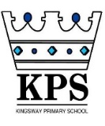
KS2 Project Year 4 – Wrens & Robins
Rivers and Coasts

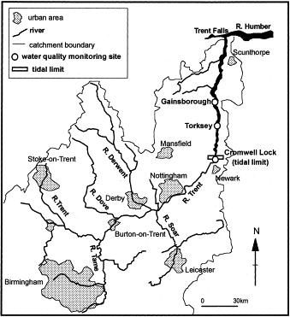

Subject Specific Vocabulary:
River – a large, natural stream of flowing water.
Reservoir – the store of water that is held back by a dam.
Source – where a river begins its journey. This is usually high up.
Tributary – a stream or river that flows into a larger river or lake.
Mouth – where a river enters a lake, larger river or the ocean.
Confluence – the point at which two rivers or streams meet.
Meander – winding curve or bend in the river. They are typical in the middle and lower course of a river.
Estuary – an area at the end of a river that is in between land and the ocean.
Erosion – the wearing away of rock, stones and soil by rivers, waves, wind or glaciers.
Floodplain – the flat land of the river valley close to the river banks.
Delta – an area of low flatland where a river divides into several smaller rivers.
Water cycle – the continuous movement of water on, in, and above earth and the changes it goes through as it moves.
Evaporation = when a liquid is heated, it turns into a gas or vapor.
Condensation – the process by which water vapor (water in its gas form) turns back into liquid water.
Precipitation – the liquid and solid water particles that fall from clouds and reach the ground.
Collection – when water is temporarily stored in bodies of water like rivers, lakes and oceans.
Runoff – the movement of water when precipitation doesn’t soak into the ground.
Coastline – the line where the land and water meet, or the boundary between the land and the ocean or a lake.

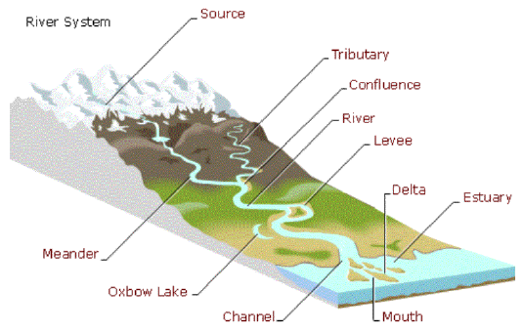
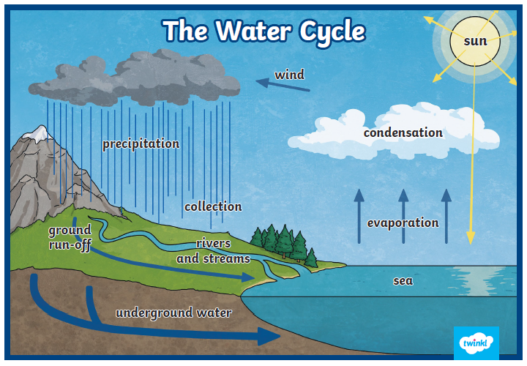
Key Places
Biddulph Moor – the source of the River Trent.
River Ouse, Humber Estuary – the end of the River Trent.
Holderness Coastline – most rapidly retreating coastline in Europe.
Key Dates and Figures

At 185 miles (294K) long, the River Trent is one of England’s major rivers. It’s also tidal, and in ancient times was navigable beyond Nottingham using this flow.

In 867 AD, the Danish Vikings came up the Trent to Nottingham and Repton in their long ships.

It is the 3rd longest river in the UK

The name "Trent" is possibly from a Romano-British word meaning "strongly flooding".
Wider Curriculum
Art: The art of display
Spanish: Let’s go
DT: Building a flood proof house.
Science: States of matter.
PE: Basketball and swimming

